**Understanding Functional Interfaces in Java**

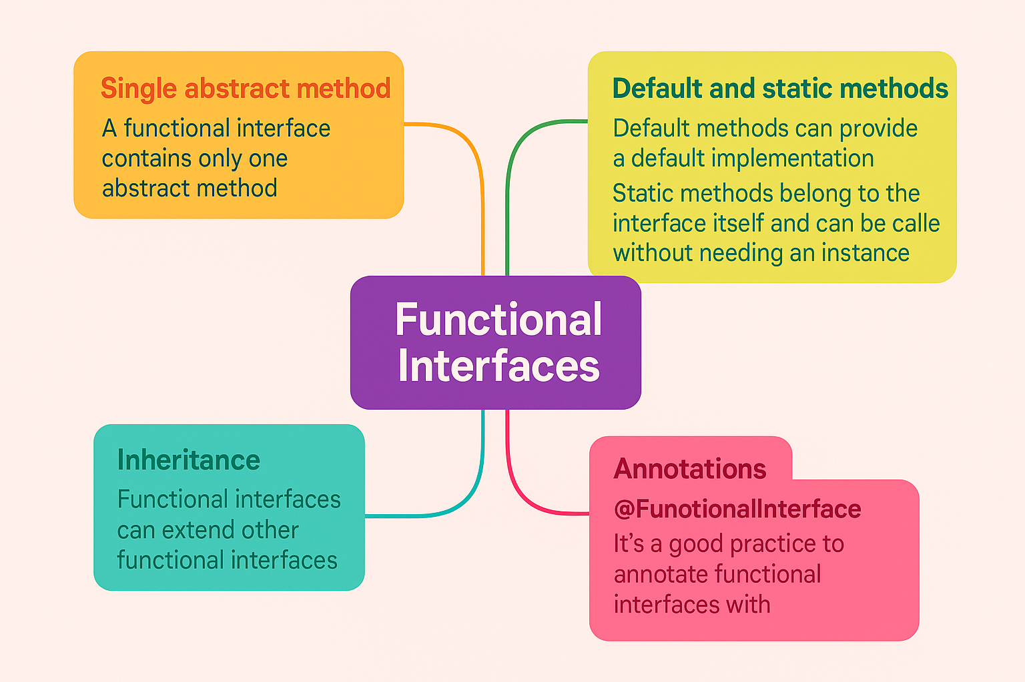

**Introduction**

In Java, a functional interface is a type of interface that has just one abstract method. This concept allows us to use the interface in a functional style, making our code cleaner and easier to read. Functional interfaces can be implemented with lambda expressions, method references, or anonymous classes, helping us leverage the power of functional programming in Java.

Features of functional interfaces

**1. Single abstract method:** As mentioned, a functional interface contains only one abstract method. This allows for clear and specific functionality when implementing the interface.

**2. Default and static methods:** A functional interface can also include default and static methods. Default methods can provide a default implementation, while static methods belong to the interface itself and can be called without needing an instance.

**3. Inheritance:** Functional interfaces can extend other functional interfaces. However, the rule of having a single abstract method still applies. If a functional interface extends another, it can't add any additional abstract methods.

**4. Annotations:** While it's not mandatory, it's a good practice to annotate functional interfaces with the @FunctionalInterface annotation. This helps ensure that your interface adheres to the functional interface contract, preventing potential errors during compilation.

**Functional annotations**

The @FunctionalInterface annotation is used to indicate that the interface is intended to be a functional interface. If you accidentally add more than one abstract method, the compiler will flag an error, reminding you to stick to the single abstract method rule. Using this annotation is optional, but it's beneficial because it aids in early error detection and improves code clarity.

**Code Examples**

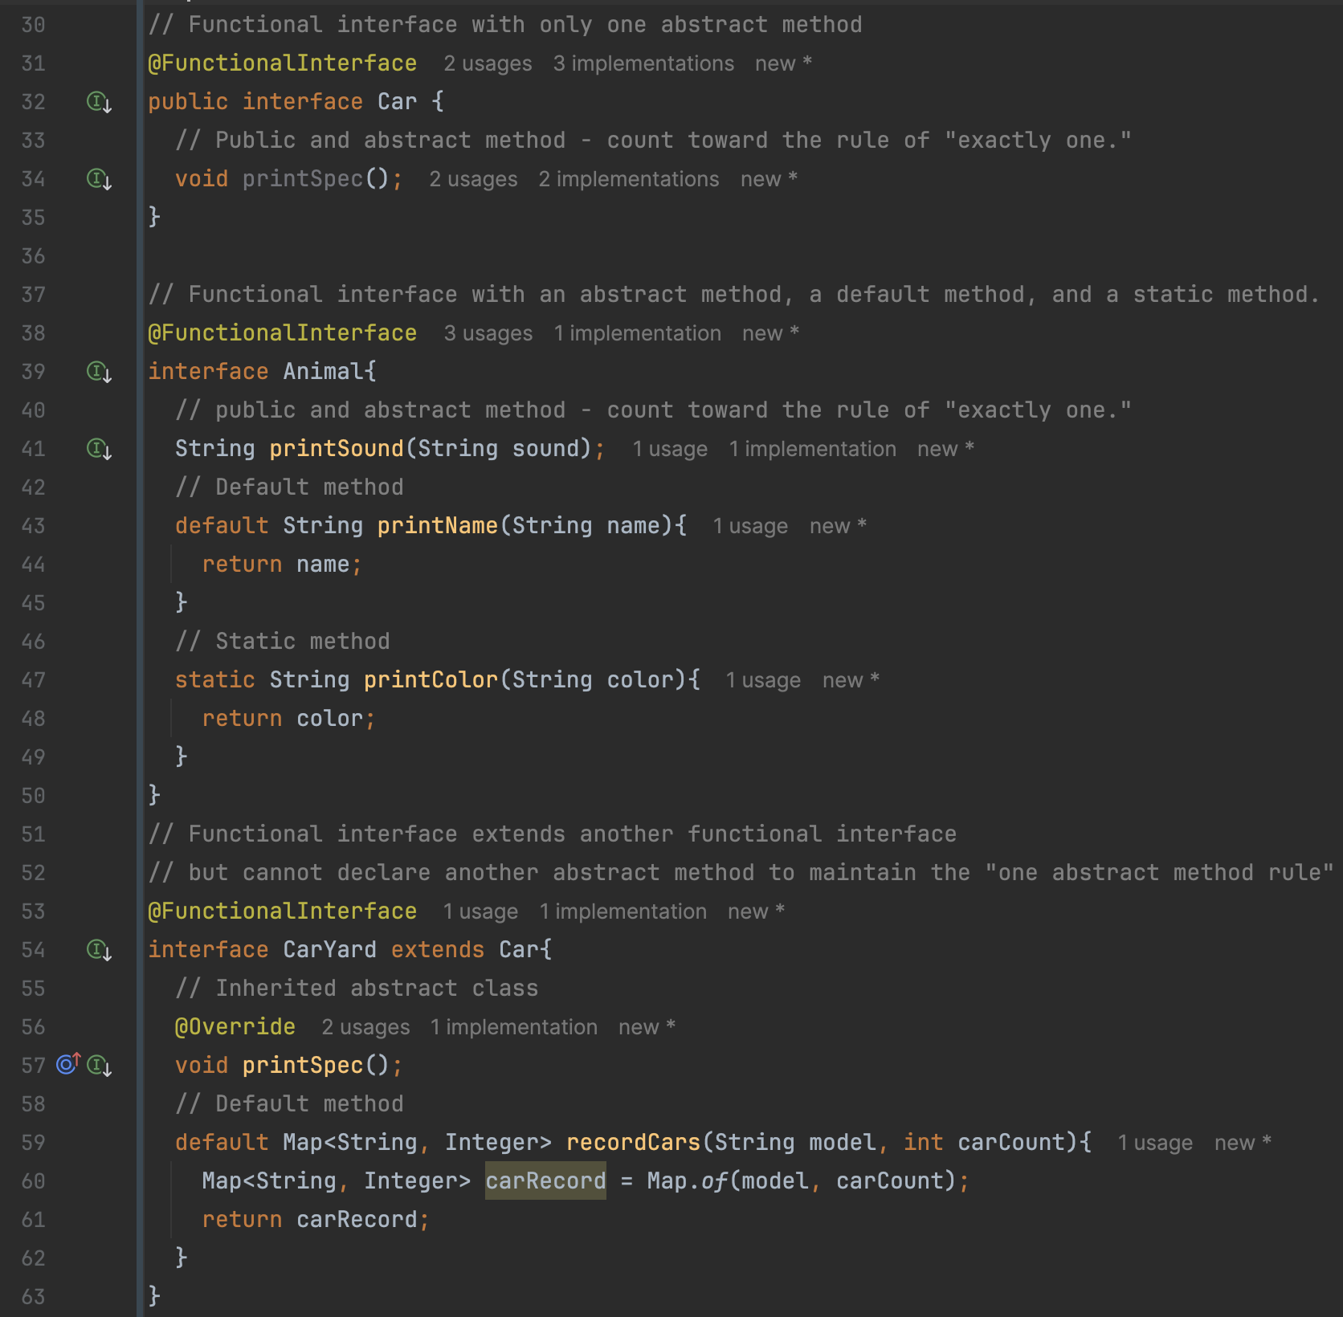

**Conclusion**

Functional interfaces bring a lot of benefits to Java programming, especially in terms of cleaner, more manageable code. By using these interfaces, we can take advantage of lambda expressions and other functional programming paradigms. Remember to use the @FunctionalInterface annotation to help ensure that you're sticking to the principles of functional programming while keeping your code easy to understand and maintain. Happy coding!